GKE Infrastructure & Blue-Green Deployment via Jenkins & Terraform
This project demonstrates two DevOps tasks implemented using a Google Cloud Platform (GCP) account:
- Task 1 – GKE Cluster Setup & Autoscaling using Terraform
- Task 2 – Application Deployment on GKE using Jenkins (Blue-Green Strategy)

Overview
- Infrastructure-as-Code: Terraform creates and manages the GKE cluster.
- Application: Simple Nginx web server.
- Deployment: Jenkins automates Blue-Green releases on GKE.
- Scaling: Kubernetes HPA (Horizontal Pod Autoscaler) handles load increases.

Task 1 — Create GKE Cluster & Demonstrate Autoscaling
Objective
Provision a 2-node GKE cluster using Terraform, deploy a sample Nginx app, and demonstrate autoscaling behaviour under load.

Steps
- Set Up Terraform
- Files:
terraform/provider.tf
terraform/variables.tf
terraform/main.tf
terraform/versions.tf
terraform/terraform.tfvars

- Deploy Cluster
- Commands:
terraform init
terraform plan
terraform apply -auto-approve
gcloud container clusters get-credentials demo-cluster --zone us-central1-a
kubectl get nodes

- Deploy Nginx Application
- Files:
k8s/deployment.yaml
k8s/service.yaml
k8s/hpa.yaml

- Commands:
kubectl apply -f k8s/deployment.yaml
kubectl apply -f k8s/service.yaml
kubectl get svc nginx-svc

- Enable Autoscaling
- Commands:
kubectl apply -f k8s/hpa.yaml
kubectl get hpa -w

Screenshots
- Nodes

- Services

- Deployments

- HPA (Horizontal Pod Autoscaler)

Outcome
Autoscaler successfully created additional pods in response to CPU load, confirming dynamic scaling.

Task 2 — Blue-Green Deployment Using Jenkins
Objective
Automate deployment of the Nginx app to the GKE cluster using Jenkins, following a Blue-Green deployment approach to achieve near-zero downtime.

Prerequisites
- Jenkins Installed (VM).
- gcloud & kubectl available on Jenkins agent.
- GCP Service Account Key uploaded as Jenkins credential.
- Cluster configured.

Steps
- Initial Manual Setup
a. Commands
kubectl apply -f k8s-blue-green/service.yaml
>> Deploy initial “blue” version:
powershell -Command "(Get-Content 'k8s-blue-green /deployment-tempate.yaml') -replace 'COLOR','blue' | Set-Content 'k8s-blue-green /deployment-blue.yaml'"
kubectl apply -f k8s-blue-green /deployment-blue.yaml
kubectl get svc app-svc
kubectl get pods

- Jenkins Pipeline (Jenkinsfile)
- Files
Jenkinsfile

- Kubernetes Manifests for Blue-Green
a. Files
k8s-blue-green /deployment-tempate.yaml
k8s-blue-green /service.yaml

Jenkins Execution Flow
- Detect active color (blue or green).
- Deploy the new color.
- Wait for rollout success.
- Switch service selector.
- Delete the old deployment.

Screenshots
- Blue-Green Deployment
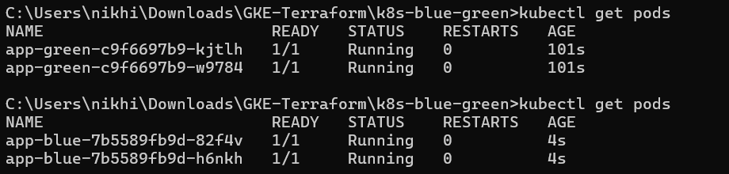
- Jenkins console output showing color switch.
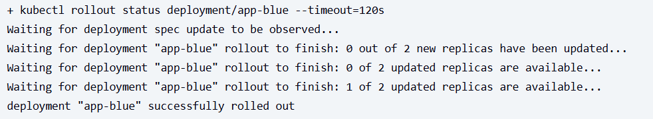

Outcome
Jenkins successfully performs Blue-Green deployments, maintaining uptime while switching between Nginx versions.

Challenges & Resolutions

Challenge | Resolution
sed command not available on Windows | Replaced with PowerShell’s -replace for cross-platform compatibility.
Trial account limits | Used e2-medium nodes and minimal autoscaling range.
YAML format errors | Verified using kubectl apply --dry-run=client.

